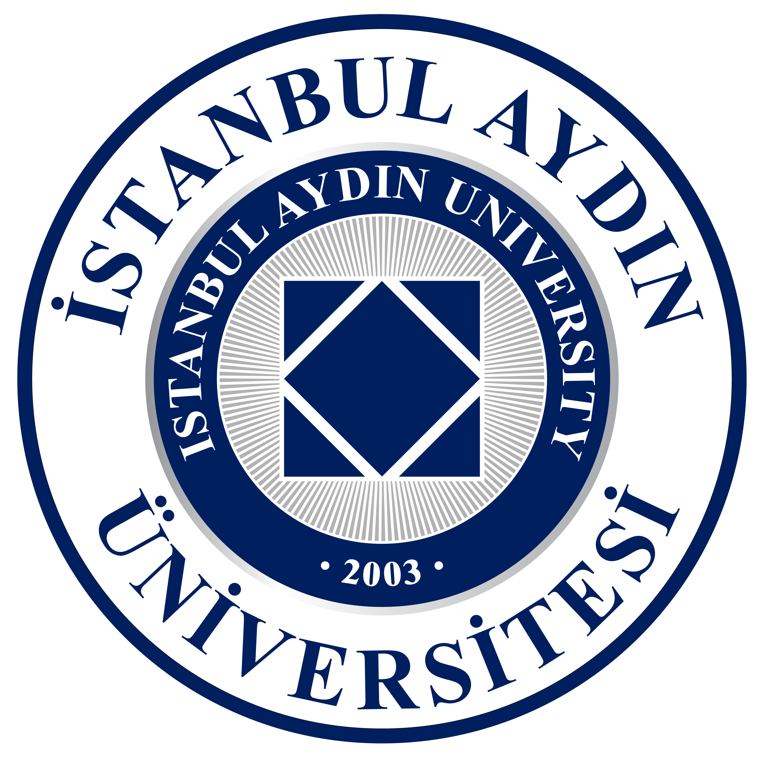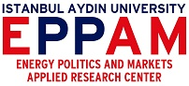
II. INTERNATIONAL SYMPOSIUM
ON GLOBAL CLIMATE CHANGE, ENVIRONMENT AND ENERGY
NEED FOR ACTION IN MANAGING MEGA DISASTERS
Sustainable Energy for Sustainable Life
CALL FOR PAPER
Abstract Submission Deadline: February 14, 2018
Announcements of Accepted Abstract Submissions: February 28, 2017
(Accepted submitters will be notified via e-mail)
Full Paper Submission Deadline: April 10, 2018
Symposium Date: April 18, 2018
Fee: €50
Venue: Istanbul Aydin University, Inonu Cad., No: 38, 34259, Sefakoy - Kucukcekmece Istanbul, TURKEY
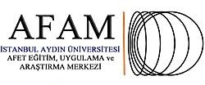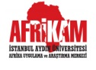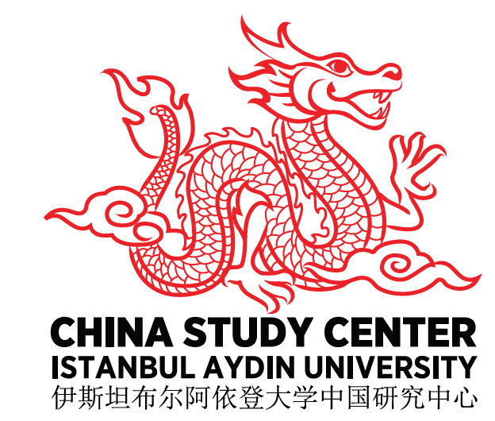
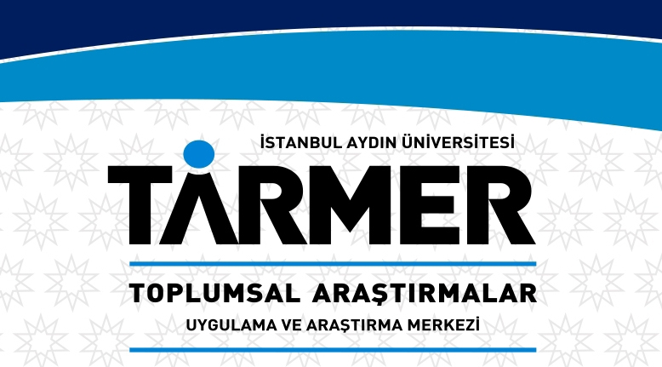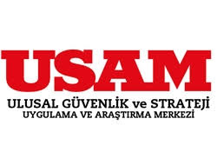
BACKGROUND

Istanbul Aydın University Energy Politics and Markets Research Center (EPPAM) aims to contribute energy policy making and development process in Turkey through conducting researches on energy politics and markets, following developments and researches on energy politics and markets, and also training experts in this area. Main areas are energy politics, energy economy and energy law.
In this context, in order to contribute to the formation and development of the managing climate change and epic disasters in assistance with the international experiences and developments, EPPAM believes that, in cooperation with Africa Application and Research Center, Anatolia BIL Vocational School of Higher Education, China Application and Research Center, Disaster Education Application and Research Center, Faculty of Economics and Administrative Sciences, Faculty of Education, Societal Studies Research Center, National Security Application and Research Center and UNESCO Cultural Diplomacy, Governance and Education Chair, organizing an international symposium focused on global climate change, environment and energy, discussing global climate change and epic disaster management in multidimensional perspective elaborating their interdependence, we will take an important step to fulfill our responsibility owned for the century and the society we belong, and we are looking for the contribution of the academia on topics related to issues given below.

MAIN THEMES
1. Global Climate Change
  - Main Problems (Environmental-Water Resources, Forests, Wildlife and Animals, Legal, Political, Economic, Social etc.)
  - Measures and Legal Issues (Bindingness, Sanctions etc.)
  - Political and Social Impacts of Climate Change (Sustainable Environment Policy, Sustainable Energy Policy, Sustainable Water Policy, Environment and Natural Resource Security, Energy Security, Water Security, Climate Migration, Climate Refugee, International Environment Regime, International Cooperation etc.)
  - Economic Dimension (Green Economy, Carbon Footprint, Carbon Market, Carbon Credit, Non-Carbon Based Economy, carbon tax etc)
  - Pre and Post COP 21 (Kyoto Protocol, Paris Agreement, Bern Convention, COP23 etc.)
2. Managing Climate Change and Mega Disasters stem from Global Climate Change
  - Impacts of Climate Change on Policies
  - Managing Mega Disasters
  - Legal Issues
  - Economic, Political and Social Dimension
- Sustainable Development Approaches
- Sustainable Energy
- Green Buildings and Energy Management, Green Building Certificate Systems
- Sustainable Environmental Education
- Sustainable Development Policies

ORGANIZATION COMMITTEE
Assist. Prof. Dr. Filiz KATMAN, Istanbul Aydın University, President of Energy Politics and Markets Research Center, Faculty of Economics and Administrative Sciences, Department of Political Science and IR (Eng), Faculty Member (Chair).
Assist. Prof. Dr. Beyhan Hilal YASLIDAG, Istanbul Aydin University, Faculty of Economics and Administrative Sciences, Business Department, Faculty Member.
Assist. Prof. Dr. Hasan Volkan ORAL, Istanbul Aydin University, Faculty of Engineering, Civil Engineering, Faculty Member, Energy Politics and Markets Research Center, Expert.
Assist. Prof. Dr. Mehmet Akif DEMIR, Istanbul Aydin University, Faculty of Education, Counseling and Psychological Guidance Department, Faculty of Member.
Assist. Prof. Dr. Nurhan TALEBI, Anatolia BIL Vocational School of Higher Education, Head of Banking and Insurance Program.
Assist. Prof. Dr. Sevket AYAZ, Istanbul Aydin University, Consultant to the President of the Board of Trustees, President of National Security Applicaiton and Research Center.
Dr. Gulmire BERDAS, Anadolu BIL Vocational School of Higher Education, Tourism Guidance Department, Lecturer, Expert at China Application and Research Center.
Lecturer Ayten CALIS, Istanbul Aydin University, Vice President of Societal Studies Research Center, Faculty of Education, Anatolia BIL Vocational School of Higher Education, Child Development Program.
Lecturer Bahar Dilsa KAVALA, Istanbul Aydin University, Vice President of Africa Application and Research Center.
Lecturer Xin ZHAO, Istanbul Aydin University, Coordinator at China Application and Research Center.
Serhat YILMAZ, Istanbul Aydin University, Project Coordinator at Disaster Education Application and Research Center.
GUIDELINES FOR PAPER SUBMISSION
- Academics to join II. International Symposium on Global Climate Change, Environment and Energy with paper should send abstract with short bio and contact to CES2018@aydin.edu.tr by February 14, 2018.
- Review of abstracts will be completed by February 28, 2018 and notifications to accepted abstract submitters will be sent to the e-mails provided in their application forms.
- Proceedings of the Symposium will be presented to the participants during Symposium, papers should be sent to CES2018@aydin.edu.tr by April 10, 2018 accordingly.
- Abstracts and papers should be in Turkish or English.
- Abstracts should be between 150-300 words and sent with a short bio, both should be typed in Word document, The Times New Roman 12 font-1.5 space.
- Full papers should not exceed 15 pages. Papers should include Turkish/English abstract, keywords and Bibliography.
- In references and bibliography, APA style should be used.
- In sessions, paper presentations will be limited to 15 minutes.
- Symposium Program will be announced on April 14, 2018 at web page.
- Each symposium applicant must provide one and only one e-mail address.
- Selected papers will be published in IJEMME journal and as an edited book.

TRAVEL AND ACCOMMODATION GRANTS

Travel and accommodation grants can be provided based on merit depending on availability within TUBITAK Grants. The amount of the grant will depend on actual travel costs.

ORGANIZING COMMITTEE

The symposium will be organized by Istanbul Aydin University Energy Politics and Markets Research Center (EPPAM) at Florya Campus on April 18, 2018.
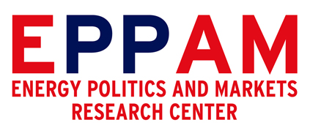
Energy Politics and Markets Research Center
Istanbul Aydın University
Inonu Cad. No: 38 Sefakoy-Kucukcekmece/Istanbul-TURKEY
Tel: +90 212 411 61 70
Fax: +90 212 425 57 59
E-mail: CES2018@aydin.edu.tr
Web Page: www.ces.aydin.edu.tr
http://www.aydin.edu.tr/en-us/arastirma/arastirmamerkezleri/eppam/Pages/default.aspx

