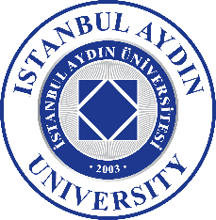
ERASMUS+ STUDENT MOBILITY STUDENT INFORMATION FORM

NAME & SURNAME
HOST COUNTRY
HOST UNIVERSITY
FACULTY
DEPARTMENT
RESIDENCE (FLAT or DORMITORY)

ADDRESS
MOBILE NUMBER

Please return this completed form, together with:

1. Arrival Form

to Istanbul Aydın University`s Erasmus+ Office via email at: erasmus@aydin.edu.tr

All fields must be completed on the computer

